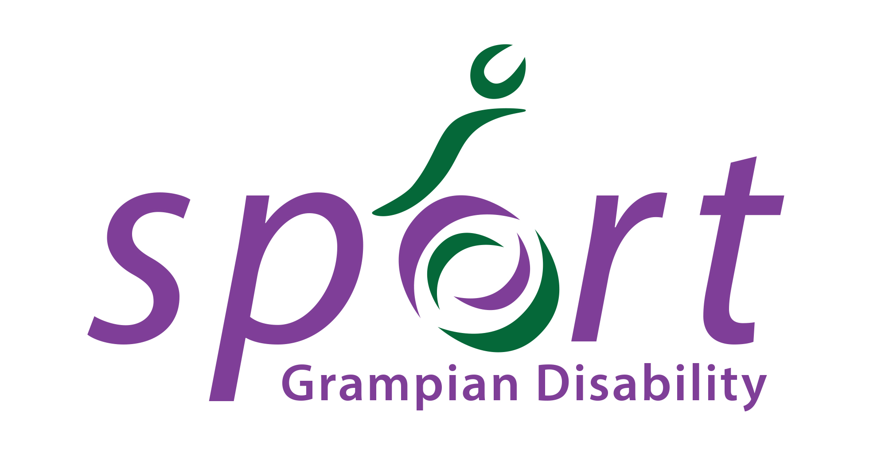
GRAMPIAN DISABILITY SPORT

REGIONAL QUALIFER FOR SDS NATIONAL LAWN BOWLS CHAMPIONSHIPS 2019

Saturday 22nd June 2019 12:30 – 16:30
Albury Outdoor Sports Centre, Albury Road, Aberdeen, AB11 6TN

Name of Bowler
Club (if any)
ADDRESS:
POST CODE: |  |  |  | Tel:
Email:
Male/Female: |  | Age: |  |  |  |  | Name of School: (if applicable)
Parent/Carer’s Name:
Contact No. |  | Email:
Will a carer accompany the participant to the session? (Please circle) |  |  | Y/N
If no, please provide the name of someone we can contact during the time of the session in case of emergencies |  | Name: |  |  |  |  | Contact Number:

Please use the space below to share further information about your disability you feel we may need to know to provide the best sporting experience for you. Please inform if you use a wheelchair or assisted devices.

Please indicate any special medical needs you may have that we should know about e.g. Asthma, Epilepsy

Please indicate any special educational needs you may have you would wish to make us aware of:

If you use sign language or have a special need relating to communication please state below and elaborate as fully as possible (e.g. do you use Makaton)

Do you consent to receiving first aid/medical treatment? (Please circle) YES NO
Photography may be used during the sessions. Images will be used in publications and on our website to publicise our services or celebrate special events. These may also appear in our printed publications, on our website, intranet, social media i.e. Facebook, Twitter and on Plasma screens in various council offices. We may also send them to the news media.
Please tick this box if you DO CONSENT to the participant being photographed and images used as indicated above □
Please tick this box if you DO NOT wish the participant to be photographed and images used as indicated above □

 | Section | Description | Tick
Entry Category | 1 | Totally Blind Bowlers
Entry Category | 2 | Bowlers who use a wheelchair and have good arms, hands and trunk
Entry Category | 3 | Bowlers who use a wheelchair but have weakness in arms/trunk
Entry Category | 4 | Male bowlers who are ambulant and not restricted by their physical impairment during delivery, plus bowlers in B3 class of visual impairment.
Entry Category | 5 | Female bowlers who are ambulant and not restricted by their physical impairment during delivery, plus bowlers in B3 class of visual impairment.
Entry Category | 6 | Male bowlers who are ambulant and restricted in their bowling arm, trunk or have balance difficulties plus bowlers in B2 class of visual impairment.
Entry Category | 7 | Female bowlers who are ambulant and restricted in their bowling arm, trunk or have balance difficulties plus bowlers in B2 class of visual impairment.
Entry Category | 8 | Male ambulant bowlers with a learning disability
Entry Category | 9 | Female ambulant bowlers with a learning disability

Entry categories will be combined if entry numbers are too low to hold standalone events.

Important Information
- The entry fee is £5 per player & should be paid on the day in cash to Albury Outdoor Sports Centre.
- Light refreshments will be available, athletes/helpers/family members should bring in their own lunch as there aren’t places nearby to buy substantial food.
- There is not a designated car park for the venue, although limited parking is available on surrounding streets (pay and display for non-blue badge holders)
- Bowlers should bring their own bowls where possible, although it may be possible to borrow some equipment on the day.
- Whites or greys should be worn as well as suitable footwear for the green.
- Competitors should ensure that they arrive on time for the event. Late entrants may need to forfeit matches.
- Matches will be played as the 1st to 21 or a limit of 40 minutes each.
- Players are responsible for ensuring that they meet the classification criteria. Please get in touch if you are not sure.

Data Protection
Please sign below to confirm that you have read and understood our Privacy Notice, which can be viewed on our website here:
http://www.grampiandisabilitysport.org.uk/documentation/

Signed: ____________________________ Date: ________________________

Athlete Code of Conduct

Aim: To ensure that all athletes/coaches involved with GDS participate within an agreed philosophy and set of standards.

Principle Statement of Ethics

Sporting integrity is based on the acceptance of rules, fairness, equality, respect for others, moral conduct and a sense of what is right. The goal of GDS is to create a sporting environment where violence, breaking the rules, the abuse of drugs, the lack of fair play and other unethical behaviour are automatically rejected as being irrelevant to the true purpose of sport.

I the athlete/coach agree to the following:

- to abide by the principle statement on Ethics above
- practice and play within the spirit of the game
- help each other to learn new skills
- compete as a team
- respect others – coach, officials, other players, team managers, parents who help organise/play the sport
- do not direct verbal, physical, emotional abuse towards opponents/coaches/umpires/event organisers & other team members
- treat all others as you would like to be treated, with integrity and respect
- arrive before the start of each session to ensure adequate preparation and to be punctual on all occasions, where possible provide information in advance if you are ill or unable to attend any session.
- set a good example at all times in aspects of dress, language, behaviour, and respect of equipment and others.

Signature: Date:

Entry forms & codes of conduct to be returned to Alison Shaw, Regional Manager, Scottish Disability Sport, Broadfold House, Broadfold Road, Bridge of Don, Aberdeen, AB23 8EE or via email at alison.shaw@scottishdisabilitysport.com. For any queries, please call Alison on 07828 744 848.

Entry form to be returned no later than Friday 14th June 2019

