Grant Application Form
&
Guidance Notes

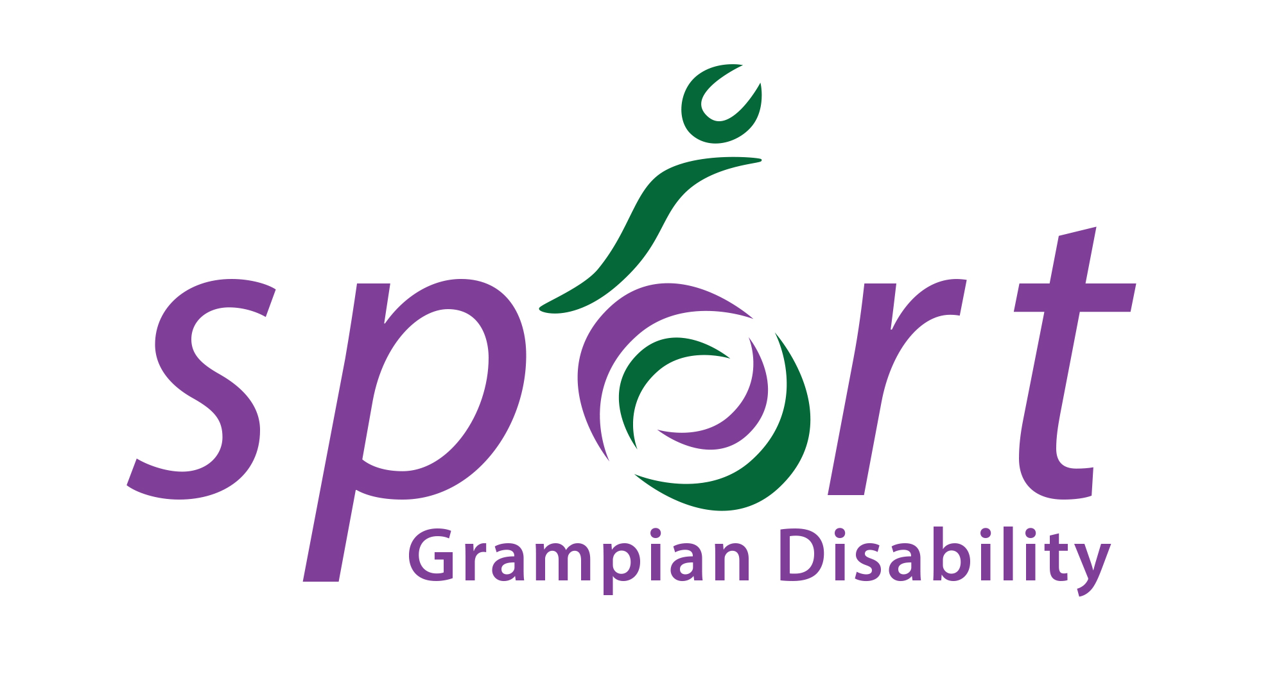
Grampian Disability Sport

Grant Aid Application
General Information and Guidance Notes

The purpose of this scheme is to provide financial assistance to clubs, associations and individuals with a disability who are affiliated with GDS to develop their sport at all levels.

Grants are operated by Grampian Disability Sport. Applications are made through the attached Grampian Disability Sport Grant Application form. Grants may be awarded for the following purposes:

National Athletes - max £500 per annum: This grant is designed for local athletes who have been selected to compete for Scotland and or Great Britain or selected for national squad training sessions. An application can also be made for acceptance of costs in principle whereby the applicant submits evidence for recent selection to a national squad along with an estimate of all associated costs for the year. Applications open to individual members only.

Regional Coach Education- Max £500 per annum: The aim of this grant is to help improve the standard of coaching and officiating at regional level. All training must demonstrate a clear benefit to participants in Grampian. The type of training are supported is NGB Awards, UKCC, Sports Coach UK (NCF) courses or Tutor Training Courses. Applications open to club/organisation & individual members.

NB: National Athlete and Coach Education applicants are eligible for up to 25% of total costs of accommodation, travel, course/tuition fees and subsistence up to the annual maximum amount as set out in the awards criteria. Original receipts must be retained and submitted in order to claim the grant award. In all cases grants will not be awarded for personal equipment, clothing, entry fees, transport of equipment or trophies/prizes.

National Event - 50% of the total costs up to a max of £250 per annum: This grant is aimed at meeting the needs of clubs and individuals with a disability where they are out with the grant criteria of Grampian Disability Sport. This grant may consider assistance with travel costs, assistance with overnight accommodation and subsistence where a coach/athlete is competing at a national event, recognised by by the events sub-group for that year. If transport has been provided from the region by Grampian Disability Sport to the event, no individual applications will be considered unless specific physical impairments prevent travel on the bus provided. Applications open to individual members only.

Specialist Equipment – up to maximum of £500 per annum: The aim of this grant will be to award clubs or individual applicants with funds towards the purchase of specialist equipment. This will only be awarded where the applicant shows that the equipment is essential to their sporting career and the piece of equipment will be used for the sole purpose of their sporting career. Applications open to club & individual members only.

Please note
Original receipts must be retained and submitted in order to claim the grant award. In all cases grants will not be awarded for entry fees, transport of equipment or trophies/ prizes.
Conditions of Grant

- Subject to all criteria being met, notification of provisional award will be made in writing or email as soon as possible after submission. The final grant paid out cannot exceed the provisional award.

- A Grant Aid Expenditure Form will be sent to the applicant once the grant has been approved by the committee. Within 3 months of completion of the course or event the form must be returned to The Chairperson, Grampian Disability Sport, with all the supportive original receipts, not copies, otherwise the grant cannot be awarded.

- In the event of a false claim or event/ course cancellation the awarded grants must be returned in full to Grampian Disability Sport..

- All athlete applicants must be resident in Grampian regardless of where they train. Coaches and officials must be resident and provide a service in the Grampian area.

- All applications for grants, awards or sponsorship from any other source must be declared on the application form.

- If an applicant is receiving financial assistance from other sources Grampian Disability Sport may opt to provide a smaller donation. Applicants receiving grants from other sources eg Lottery, etc for the specific application are not eligible if the combined awards will exceed the expenses incurred by the applicant.

- Grampian Disability Sport will consider all grant applications on their merits using the above conditions and is under no obligation to offer a grant to any or all applicants. No discussion or correspondence will be entered into with regard to refusal or of the size of grant award. All grants will be considered at the discretion of the Committee.

Grampian Disability Sport
Grant Application Form

Name……………………………………………………D.O.B…………………………………… Sport………………………………………………

Address….……………………………………………………………………………………………………………………………………………….…….

Postcode…………………………………………………………… Email…………………………………………………………………………………

Telephone……………………………………………………….. Mobile……………………...……………………………………………………….

Is the application on behalf of (please tick)

(a) Club (b) Individual (c) Organisation (d) School

Are you in receipt of any grant/expenses/sponsorship in connection with this application? (Please specify in detail)

………………………………………………………………………………………………………………………………………………………………………….

Are you intending to apply for grant assistance from another source(s)? YES / NO

Please specify:……………………………………………………………………………………………….

Please Note - “Specialist Equipment” Grant: Applicants must submit a letter detailing how the grant will be used, how this will develop the club/individual and details on income/sponsorship received to date, in respect to the total costs for the piece of equipment. The chairperson (Club) or a referee (individual) must be able to verify this application and any subsequent grants offered in relation to this application.

Dates | Description of event / course / training session  Please give details on venue | Costs |  |  | Totals
Dates |  | Accom | Travel | Tuition
Total Costs |  |  |  |  | £

Declaration – I have read and understood the conditions of grants. I understand that any misinformation will result in the rejection of this application.

If form not completed by applicant please state relationship

Signature of Applicant……………………………………………………………… Date…………………………………………

Relationship to Applicant (if applicable) ………………….…………………………………………………………..

Please return completed to: Grampian Disability Sport, Chairperson at Craigievar House, Howe Moss Avenue, Dyce, Aberdeen, AB21 0GP or email: info@grampiandisabilitysport.org.uk

Office use only

Grant Aid Refused: Comments……………………………………………………………………………………………..

………………………………………………………………………………………………………………………………….

Provisional Grant Aid of £……………………………………approved. Comments…………………………………….

………………………………………………………………………………………………………………………………….

Secretaries Signature………………………………………………………………………………………………………..

Chairpersons Signature……………………………………………………………………………………………………

Date of acceptance / rejection letter………………………………………Date grant issued…………………………..

